

K1 CSE3023 PEMBANGUNAN APLIKASI BERASASKAN WEB
LAB REPORT 3
SEMESTER 4

PREPARED FOR: ASSOC. PROF. TS. DR. WAN NURAL JAWAHIR
LAB ASSISTANT: MISS WAN FATIN

PREPARED BY: AKMA ASYIFA BINTI ZULKARNAIE
NO. MATRIC: S75186
DATE: 14 APRIL 2026

Lab Module 3 – JSP: Scriplet, Page, Directive & Include Directive
3.9 Exercise
Source Code:

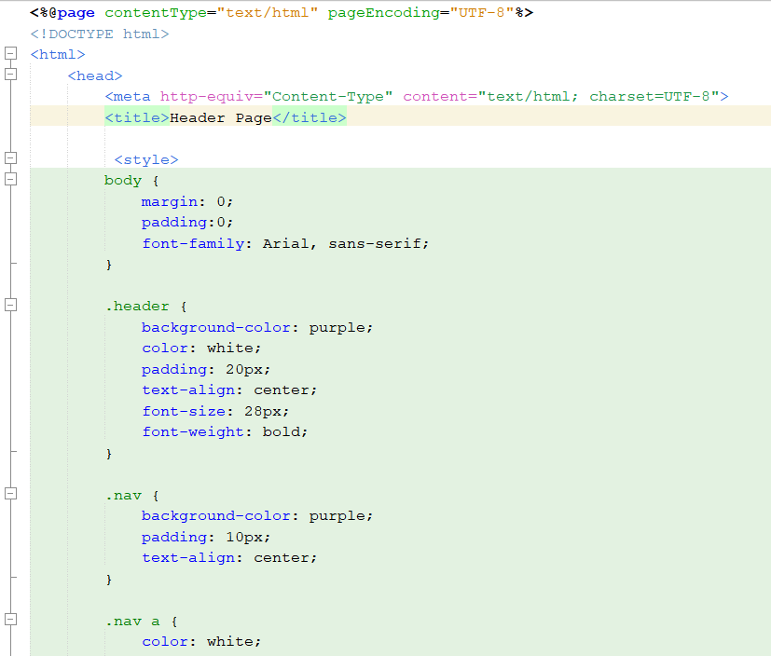
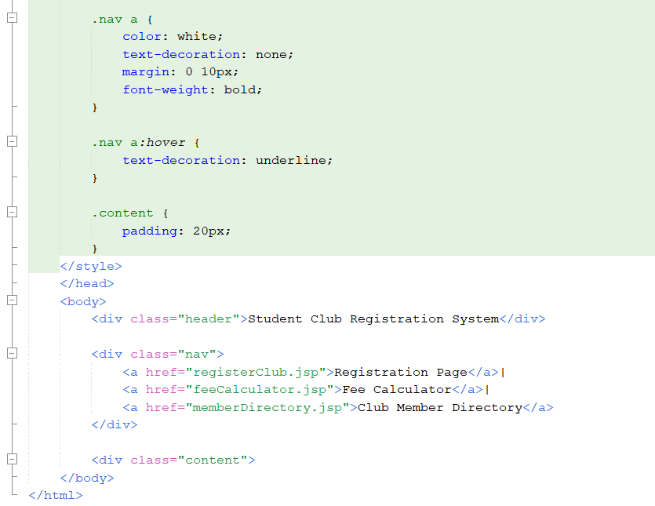
Figure 3.0: Header.jsp
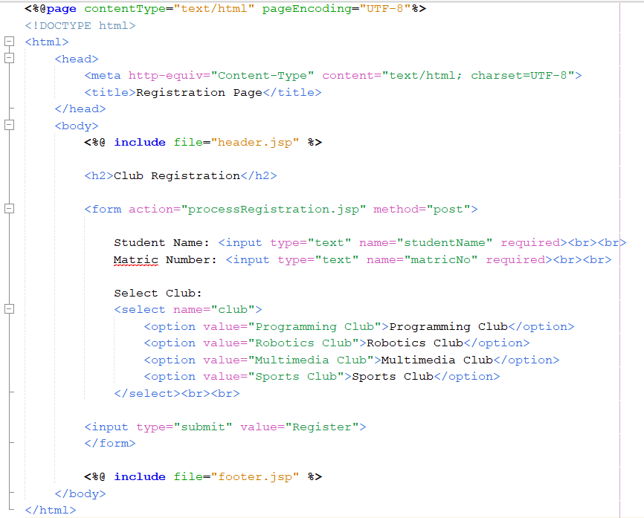
Figure 3.1: registerClub.jsp

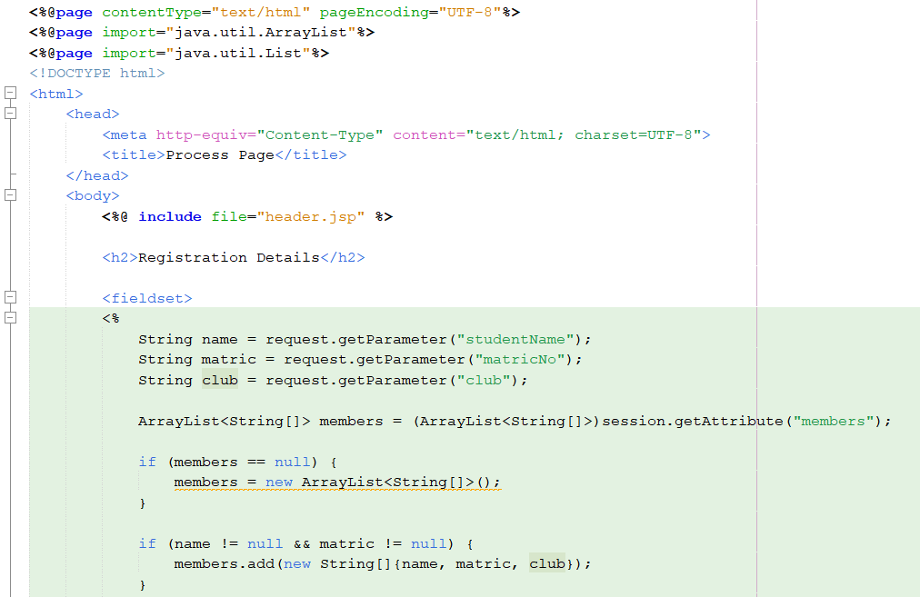
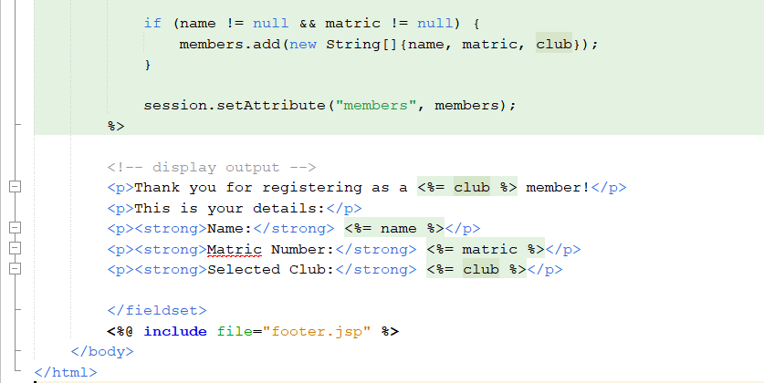
Figure 3.3: processRegistration.jsp

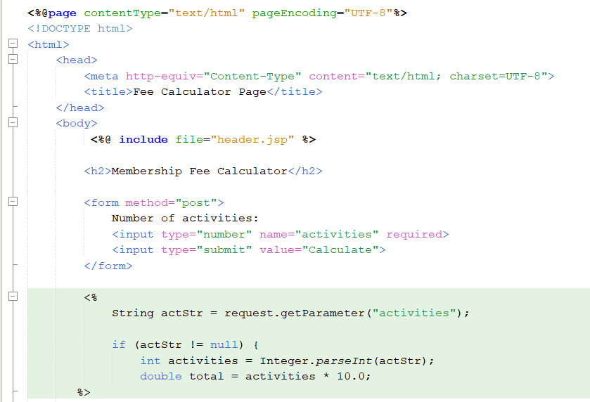
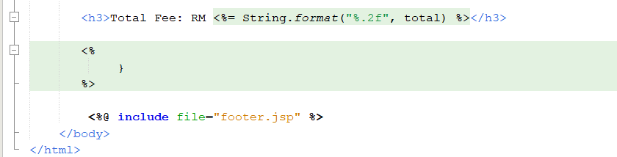
Figure 3.4: feeCalculator.jsp

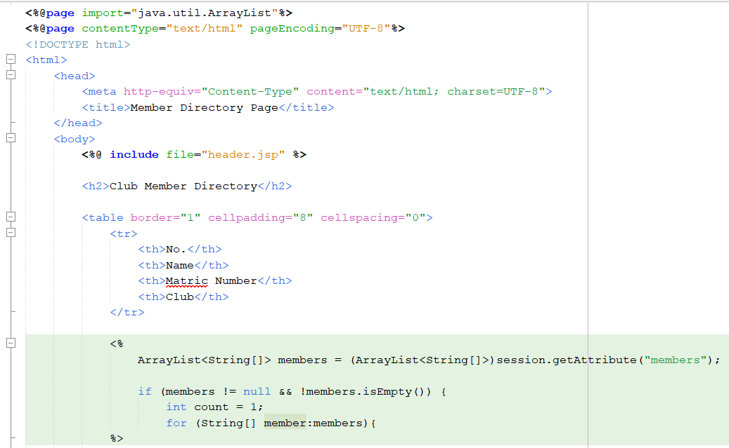
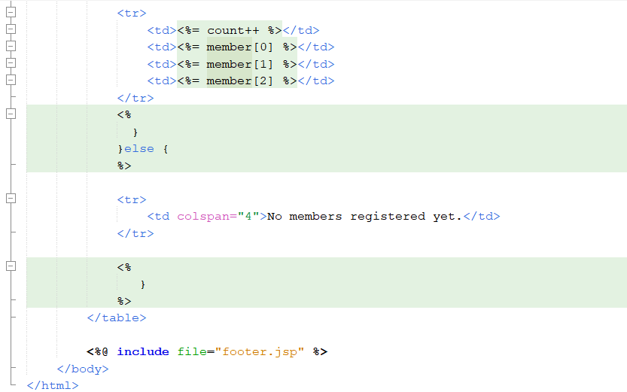
Figure 3.5: memberDirectory.jsp

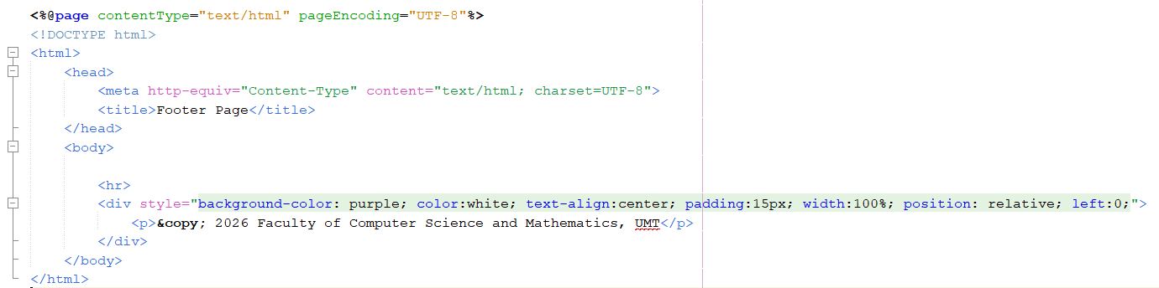
Figure 3.6: Footer.jsp

Output:

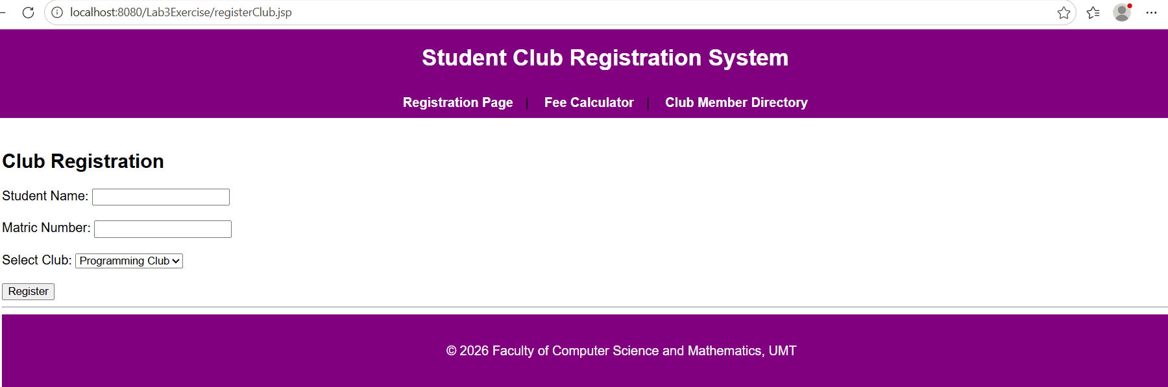
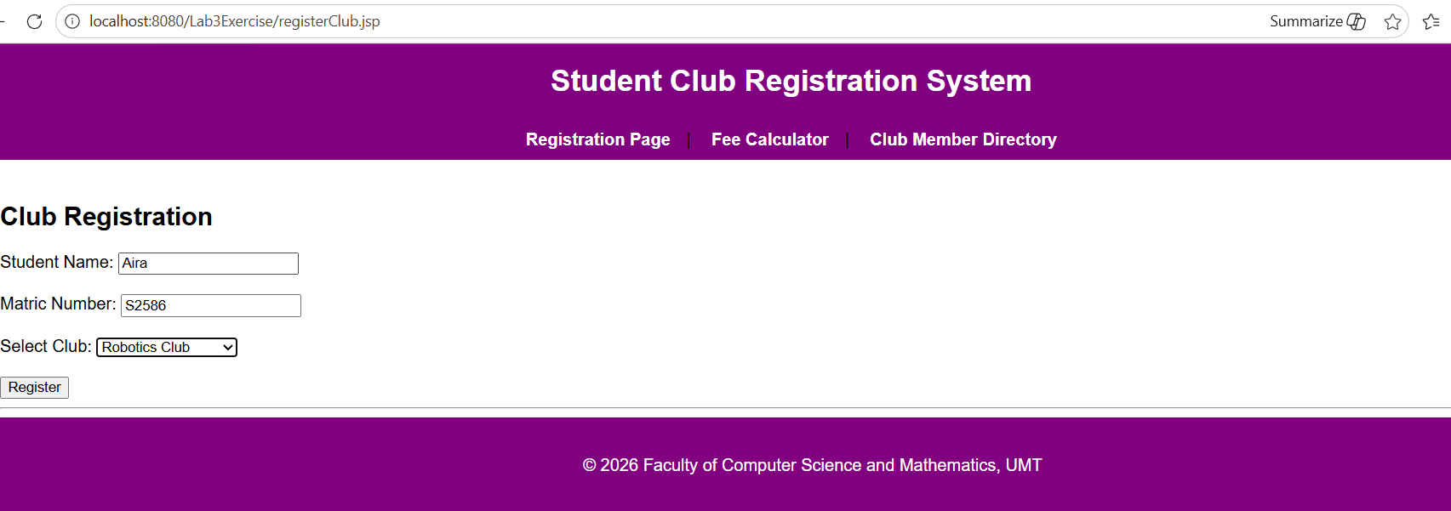
Figure 3.7: Club Registration Interface

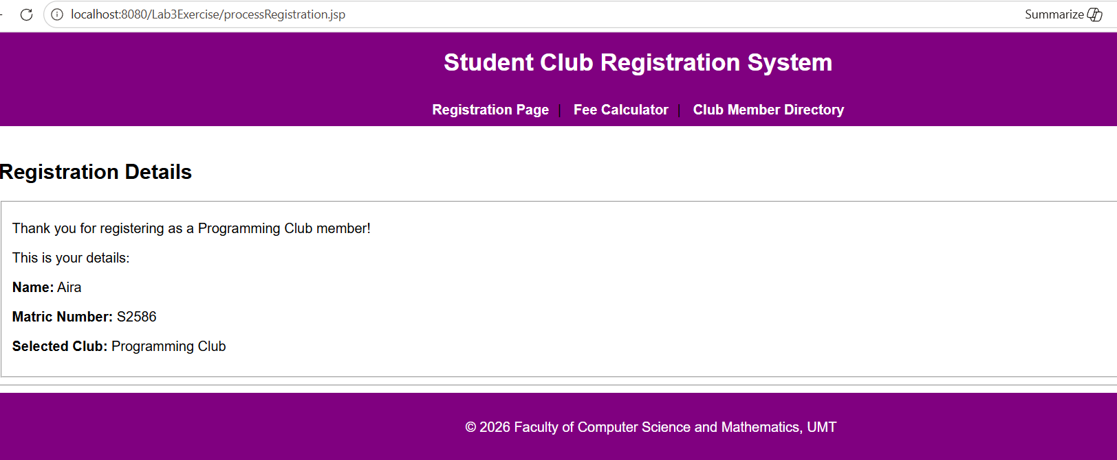
Figure 3.8: Registration Details Interface
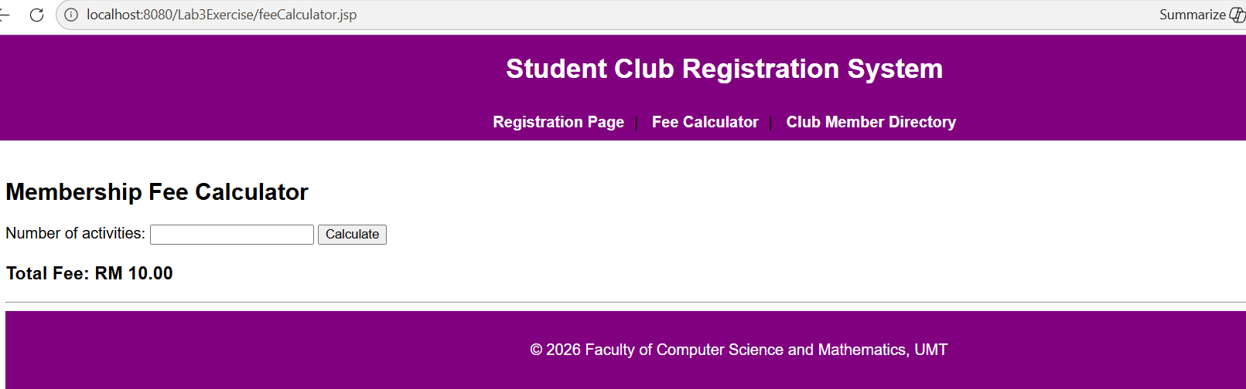
Figure 3.9: Membership Fee Calculator

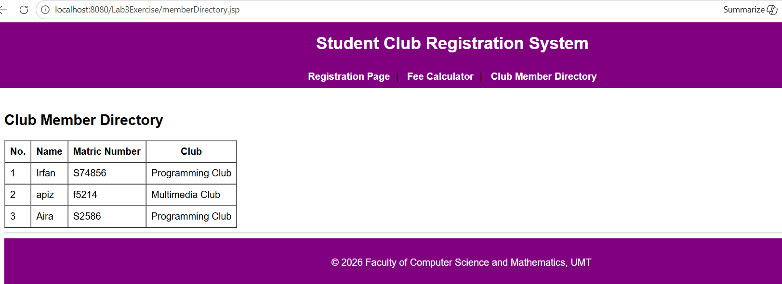
Figure 3.10: Club Member Directory

